EAGLE VIEW EQUESTRIAN CENTRE – RULES 2022
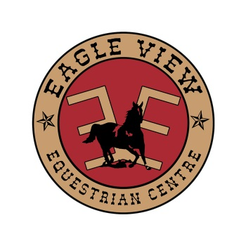
- No Smoking in Arena, Barn or Grandstand.
- Members Only. All unregistered non-members must have permission prior to riding.
- All riders, instructors and handlers must sign an annual liability waiver.
- Children 16 and under must be accompanied and supervised by an adult while on the property.
- Riders 10 and under MUST wear an approved helmet.
- Appropriate footwear must be worn while riding (no running shoes or flip flops).
- Do NOT tie to metal panels!
- No DOGS allowed in the Riding Arenas. Dogs may be allowed on site on a leash.
- During OPEN/Shared Riding Times, no use of equipment or activities that monopolize the arena, unless it is okay with all others in the arena.
- Ride safely and with courtesy – riders must be in control of their horse(s) at all times and follow proper arena etiquette.
- Clean up manure and garbage before you leave the premises.
- Close gates and doors. Turn out lights if you are last to leave.
- Horse Council BC membership recommended.
- Coaches must be accredited and provide their own insurance.
- Enjoy and respect the facility, management and members.
During the Covid-19 pandemic, current rules will be posted as required by the PHO.
Rider Limits may be imposed.
Please do not come if sick or if you have been in recent contact with a sick person!
Hand Sanitize before you enter the building. Keep a safe distance away from others outside your bubble or wear a mask.
WEBSITE: For up to date scheduling and info eagleviewequine.net

